Changing to a stronger bit
How do mullen mouth bits, Pelham and Co work and what is best for me and my horse?
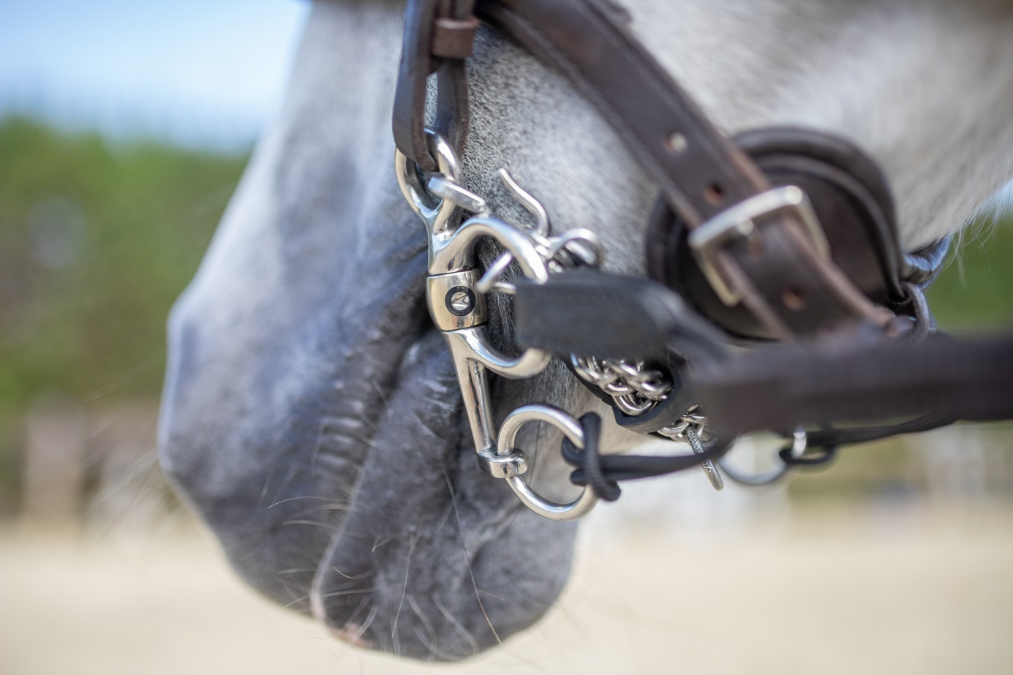

Important suggestions at the beginning
- Basic requirements are a healthy horse and suitable equipment
- A bit can neither replace good riding and training nor solve rideability or health issues
- Fine aids are required, a bit is as strong as the rider's hand
- The basic steps, e.g. size selection and mode of action of the most common mouthpieces, are summarized in the brochure "Find the right bit in 4 easy steps" and can be downloaded here: https://pferdesport.sprenger.de/en/info-service/catalogues-brochures/?cHash=acbaa880f5d7489a2ff55eeb56192e97

Bitting is a difficult subject. There are many opinions, many experiences but comparatively little knowledge. For some riders, a change of bit is promising to solve specific problems. In many cases reality shows that these problems often do not get smaller but the bit collection larger.
It is to be said that a bit is not a problem solver, but rather a medium of communication between rider and horse. In order to use this tool of communication in a way that the horse understands us better, it must fit the needs of horse and rider. The difficult task is to find a suitable bit for the mysterious horse's mouth and that will have the desired effect.
Often advice can help. Specialist equestrian retailers, trainers and experienced riders are good candidates to ask as they have gained experience with different types of bits. However, it is not always possible to transfer one's own knowledge exactly to other rider and horse combinations. A quick advice for strong horses for example often looks like this: "Try a Pelham, it works for mine too". The effect of Pelhams and for which "strong" horse type their use is not recommended will be discussed below in detail. The key word in this tip is "try". Because it can happen to you that the character and will of the horse decides against the carefully made choice of the rider.
Although the bit in itself is not the ultimate problem solver, the right choice of bit can make a significant difference to the cooperation between rider and horse. This leads us to the core of this article, which is intended to provide an overview of a selection of the most common bit variations that are suitable for show jumping and eventing horses, as well as leisure horses.

1) Mullen Mouth bits
Depending on the model, mullen mouth bits can be suitable for sensitive up to very strong horses. The choice is huge and depending on the style, the mode of action can vary enormously. These are the most important variations and basic rules:
The successful use of mullen mouth bits depends on an even connection to both rider's hands as they tilt when the rein aid is given single-sided. The rider should therefore be able to ride his horse through turns with seat and weight aids. Riding in flexion or bending is not possible with rigid mullen mouth bits and only to a limited extent with flexible mullen mouth bits. Therefore this type of bit is less suitable for horses that are difficult to turn.

Bits with locking effect
A particularly interesting bit on the way to a stronger impact is the so-called Max-Control bit. It is a double-jointed bit that locks at a certain angle and becomes a bar. This simply means that the effect with a loose connection and the action of the rider is comparable to a normal double jointed bit. If the horse gets strong or if the rider has to exert more force, the effect on the tongue becomes more pronounced, like a mullen mouth bit. If the connection between horse and rider gets lighter again, the bit reacts like a normal double jointed snaffle.
Such bits are suitable for corrective purposes or for horses that, depending on the situation, sometimes need a little stronger influence. The versatile mouthpiece is also available in combination with various side parts, for example as D-ring bit, Full Cheek or Pelham.
Rigid and straight mullen mouth bits
The straight and rigid bar has the strongest effect among all common mullen mouth bit types. It is particularly suitable for very strong horses that "push against the rider's hand" and are difficult to regulate. This can also be due to anatomical reasons and can often be observed in horses with a thick neck and a strong neck muscles. However, this type of bit is often successfully used for horses that lay very heavily on the hand and pull down.
With a straight bar, the pressure on the tongue is distributed very evenly over the entire tongue width. Compared to jointed bits, less pressure is applied to the edges of the tongue with straight bars. On the other hand, even with a given rein there is a slight pressure on the tongue, which naturally increases as the reins are tightened which requires a sensitive and trained rider's hand.
Flexible and straight mullen mouth bits
For flexible bars with a straight mouthpiece, the effect is noticeably different from the rigid bar. The pressure is also distributed over the entire tongue when the reins are tightened, but becomes stronger towards the edges of the tongue.
These bits are recommended for horses that occasionally tighten up or show a lack of submissiveness when training and jumping. Often these bits are well accepted by sensitive horses, not least because they are almost without exception made of rather soft materials such as plastic, rubber or leather.
Please be aware that there are a number of things to consider when it comes to selecting materials. It should be UV-resistant, food safe and not contain any plasticizers. In addition, a steel core is recommended to prevent the bit from being bitten through or breaking apart.
The following applies to the surface texture: The smoother the surface, the better the suitability for horses that have a sensitive. Rubber, for example, has a very dull surface and can rub and cause injuries in horses that salivate too little. Unfortunately, riders who actually want to do something good for their horses with sensitive corners of the mouth by means of a soft rubber bit still experience this regularly. However, the problem is often made worse by the above described eraser effect.
The Flex Control bit from Sprenger is a combination of robust and high-quality metal and rubber. The combination of the two materials addresses the tactile sense of the tongue. The soft, rubberized middle part lies on the sensitive middle of the tongue.

Mullen mouth bits with port
In comparison to straight bars, bars with port relieve the middle of the tongue until the reins are tightened. These bits are usually suitable for horses that occasionally get strong and push against the hand, have particularly thick and fleshy tongues or to correct tongue problems on horses that feel pressure on the tongue as unpleasant and react with pulling up or sticking out the tongue.
We also find a large selection of materials and degrees of hardness for these types of bits. For all of them it is important that the port has soft transitions and has no edges that could constrict the tongue and/or exert too much pressure. Furthermore, the port should be slightly tilted forward so that no pressure can be exerted into the sensitive palate.

2) Bits with leverage effect
The main point of action that is addressed in horses via a bit is the tongue. All bits containing a mouthpiece act on the tongue, which consists mainly of muscles. When using a bit with leverage effect, additional points of effect on the horse’s head are addressed. That means that the pressure exerted by a rein aid not only affects the tongue but is distributed to different influence points.
When using lever-action bits, the rider primarily affects the tongue and poll. When using a curb chain or chin strap, in order to limit the pressure on the sensitive poll, the lower jaw is also addressed. For choosing a bit it is important to know and understand how horses react when pressure is applied to the influencing points and why one wants to cause this reaction.
The theory behind bits with leverage effect:
When using snaffles, eggbutt, D-Ring or Full Cheek bits, the rider communicates with the horse via the tongue. The tongue consists mainly of muscle tissue and cushions the pressure the bit exerts onto the lower jaw. The rider tells the horse how to react by using asking and giving rein aids.
.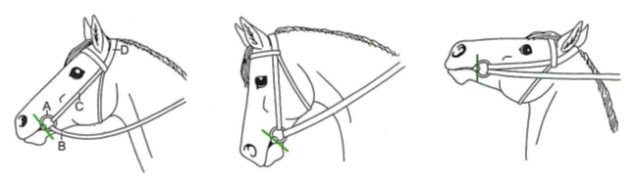
If it happens that the horse evades the reins by raising its head, the rider can no longer address the "tongue" and loses control. The bit no longer affects the tongue, but moves into the free space towards the molars.
To regain control in such situations, pressure can be applied to the neck by lever-action bits. The poll of a horse is very sensitive and to avoid this pressure horses start to lower their head which enables the rider to act on the tongue again and regain control. The rider should be careful not to exert pressure to the poll too much or too long and should release the pressure as soon as the horse lower its head.
For the use of lever bits, the rider should have a balanced and independent seat and be able to give differentiated and sensitive rein aids.
For horses that basically have a too low head position or pull down, these bit forms are counterproductive, as they further intensify this problem.

3-Ring bits
Due to the different rein options they offer, 3-ring bits are very versatile to use. The mouthpiece can slide in the ring, which allows the poll pressure to be increased to a larger extent than the pressure on the tongue. This is especially an advantage for keen or strong horses that react sensitively to higher levels of tongue pressure and start tossing or rising their heads and get really strong when the rider needs to take particular action to achieve a better control over the horse.
A big advantage of 3-ring bits is that they offer several possibilities of attaching the reins, which can be used to change the intensity of the leverage effect. If you buckle the reins in the larger ring there is no poll pressure at all and the effect is similar to a normal snaffle. If you attach the rein to the lowest ring you get the highest degree of poll pressure. By attaching the reins to different bit rings the rider has the possibility to adjust the intensity of the leverage and pressure that is exerted onto the poll.
The strength of the poll pressure also depends on the length of the lever arm of the side part. In this point the available models differ from each other a lot.
Since on Multiring bits the smaller rings are integrated in the normal bit ring, they have the shortest distance between the upper and lower ring and the least effect of leverage.
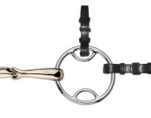
Rein options:
Cheekpiece in the upper ring, reins in the normal ring = effect of a normal snaffle, impact on the tongue.
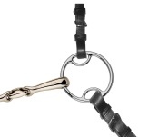
Cheekpiece in the upper ring, reins in the lower ring = impact on tongue and poll.
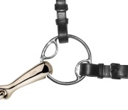
Cheekpiece in the normal ring, reins in the lower ring = strong impact on the tongue, no poll pressure.
Since the poll pressure is relatively low due to the short lever arm of this bit, it is ideal for horses that occasionally require a little more control, but are also sensitive and basically respond to the rider’s aids.
Universal- and 3-Ring bits follow the same principle. The Universal-bits have a slightly lower leverage effect as the regular 3-Ring bits.
Here too, there are a variety of rein options for adjusting the leverage. In general, the deeper the reins are buckled, the more pressure is exerted on the poll. The longer the leverage arm, the slower the bit reacts to the rider's hand.
Reins in the middle ring = impact on the tongue only, like a normal snaffle.
Bit converter in the middle and lower ring, reins in the bit converter = medium leverage effect, easy use for the rider.
One pair of reins each in the middle and the lower ring = the leverage can be varied in a targeted manner by taking and giving the lower rein. This option theoretically gives a rider the best possibility to react to the horse, in practice it is only recommended for experienced and sensitive rider hands.
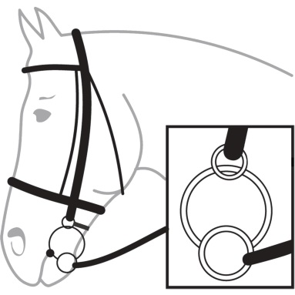
One pair of reins in the lower ring = maximum leverage.
In order to limit the leverage, which is especially useful when the reins are attached in the lowest ring, a chinstrap can be used additionally. The chin strap is to be buckled in the upper rings and has two functions: On the one hand it limits the poll pressure, on the other hand it acts on the lower jaw to counteract a "diving down" and prevent the horse from rolling in too much and thus losing the overview in jumping, for example.

Pelham
The mouthpiece of a Pelham is firmly attached to the cheekpiece. As a result, the bit acts relatively direct on the tongue and has a calm position in the horse's mouth. Ideally, the cheekpieces should lie closely to the corner of the mouth to provide a lateral limit and prevent slipping. The curb chain should be attached in such a way that an angle of approx. 30 to 45 degrees is allowed between the mouth gap and the lower cheek. The curb chain limits the pressure on the poll and counteracts the horse lowering the head too much. Since the lower jaw in the chin groove is very sensitive and the bones are only covered with a very thin layer of skin, a curb chain guard should be used as a cushion.
The length of the lower cheeks plays a big role in the effect of a Pelham. Short cheeks, react faster than longer ones whereas longer cheeks allow to apply more pressure to the poll.
Because reaction time is especially important in jumping and courses, Sprenger primarily produces pelhams with short cheeks because the rider can simply react quicker and, most importantly, release the pressure more quickly. Especially shortly before the jump or in the jump phase, pressure on the tongue and neck can have a negative effect on the scope and may lead to mistakes.
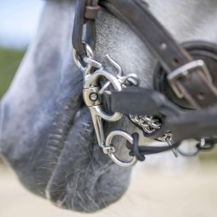
The Pelham also has different rein options. In most cases one pair of reins is buckled into a bit converter. However, it is also possible to use only one or two pairs of reins.

Gag bits
Gag bits act on the poll, the tongue and the corners of the mouth. Unlike 3-ring bits and Pelhams, this type of bit is very well suited for horses that lean on the bit or pull downwards significantly.

The gag cheek piece is guided through the bit ring and attached directly to the reins. When the rider takes the reins, the pressure on the poll increases and the mouthpiece moves towards the corners of the mouth, causing the horse to elevate and prevents it from pushing down against the hand. The use of two pairs of reins is ideal, because this allows the rider to act in a targeted and effective manner.
In conclusion, it can be said that the choice of the right bit depends on many factors. However, with a basic knowledge of how different types of bits work and a healthy self-assessment of the rider's own ability to evaluate himself and his horse, finding the right bit should be much easier and mistakes less likely.

